**Lesson63 Azure Web App - Web Jobs**

**Notes: -**

**1-Azure web jobs is feature of azure web app that allow you to run background tasks**

**(such as you have azure web app and you want to deploy some JavaScript code in background job)**

**2-Azure web jobs can host any type of scripts , it could be power shell script, command line utility , executable , you can have JavaScript in Python**

**(you could also create dotnet code which uses the web job SDK itself)**

**(so you can write your own custom script in the azure web job and set it as part of the azure web app)**

**(some job take time about 10 – 15 seconds)**

**Web Job Types**

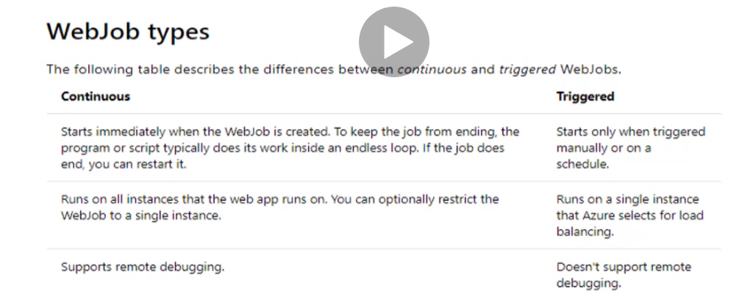

**Steps: -**

**1-we create notepad and apply the following code and save it as extension of .bat**

**2-we create azure app service and then create web job and select the .bat file and select the type (continuous or triggered) , Scheduled or Manual**

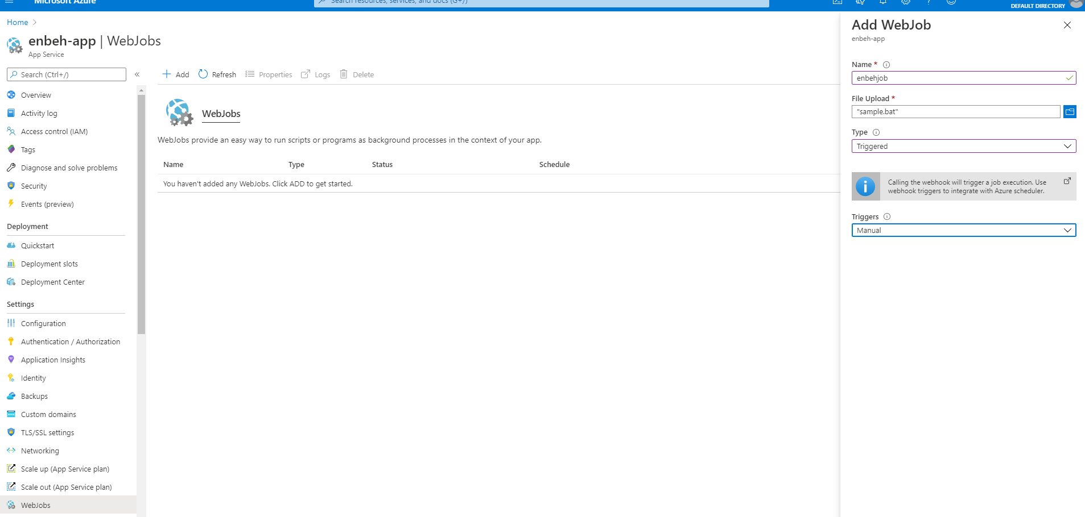

**3-click on the Run button to run background job as belo**

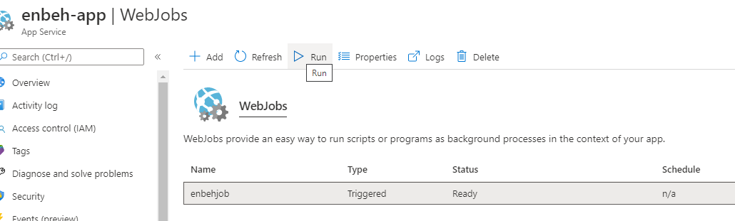

**4-click on the Logs button and you can see logs on the background job as below**

